**S3 Tasks**

1) Create s3 bucket and upload some objects to s3.

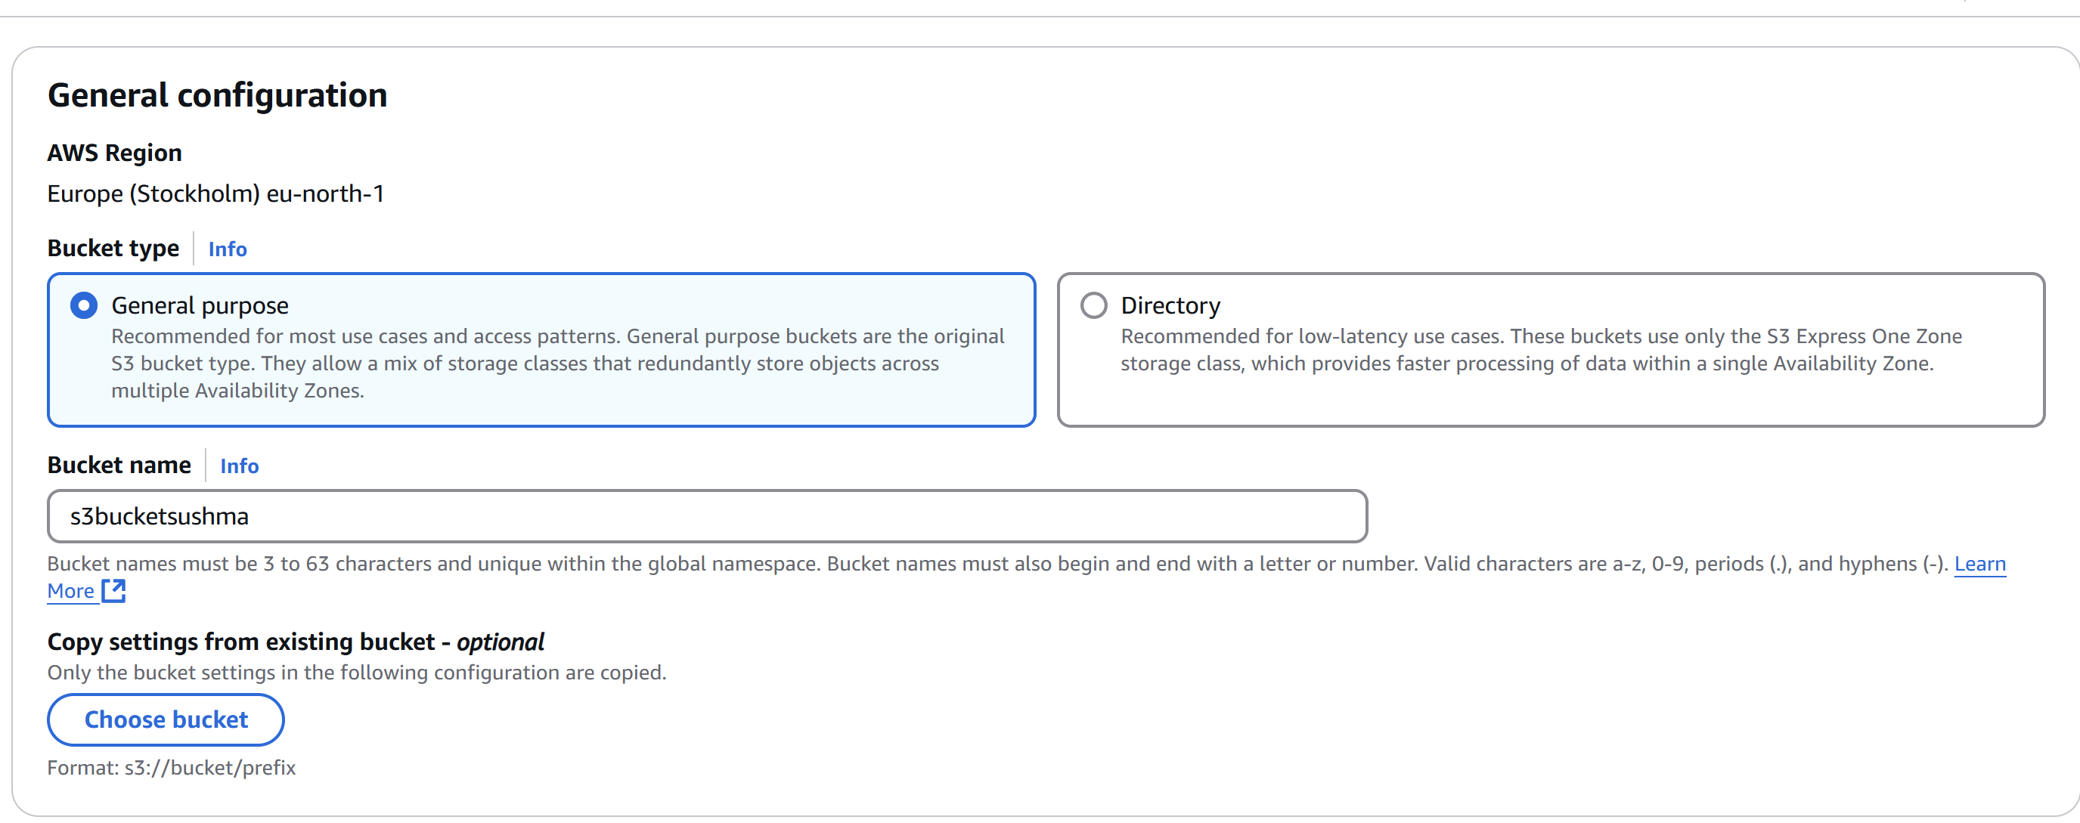

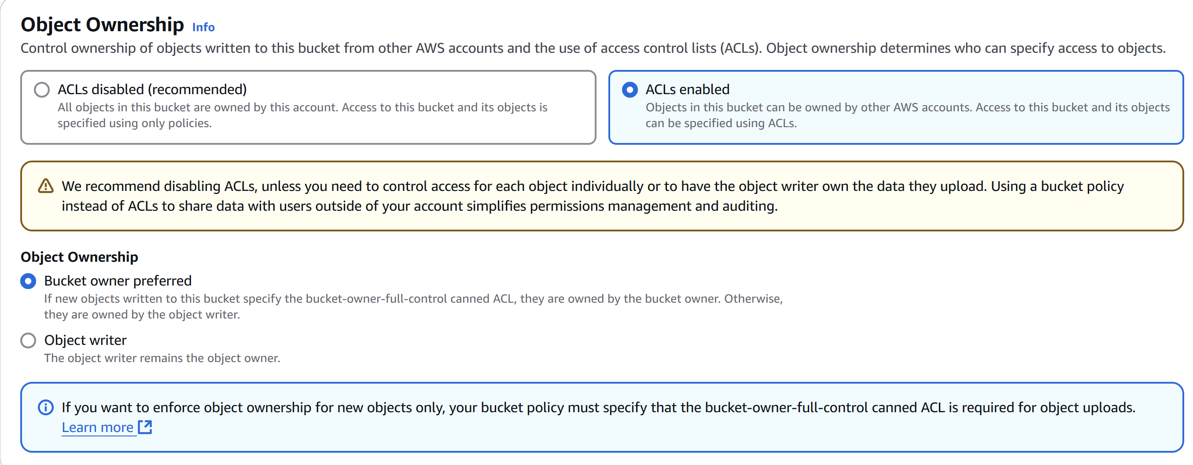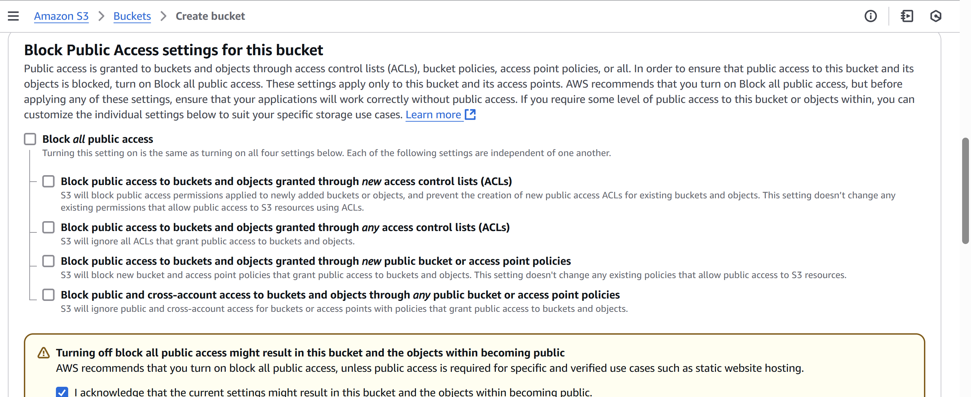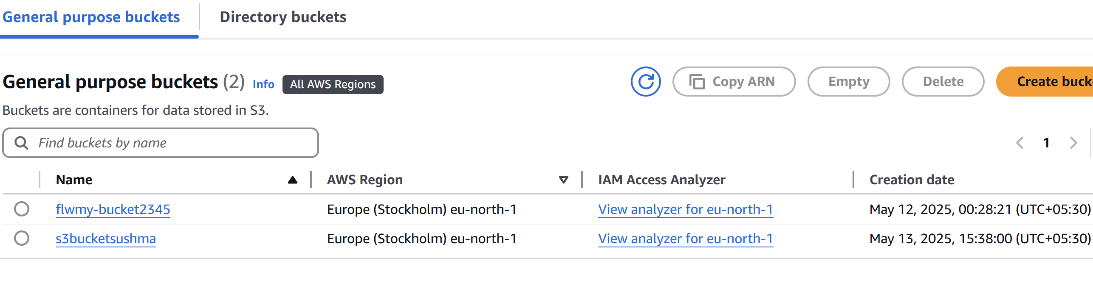

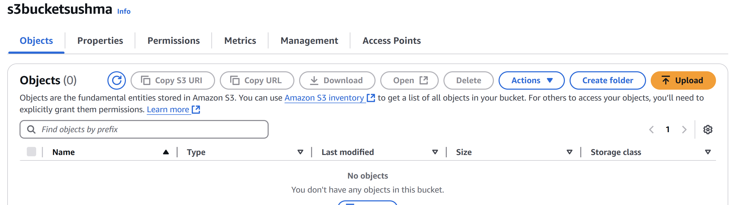

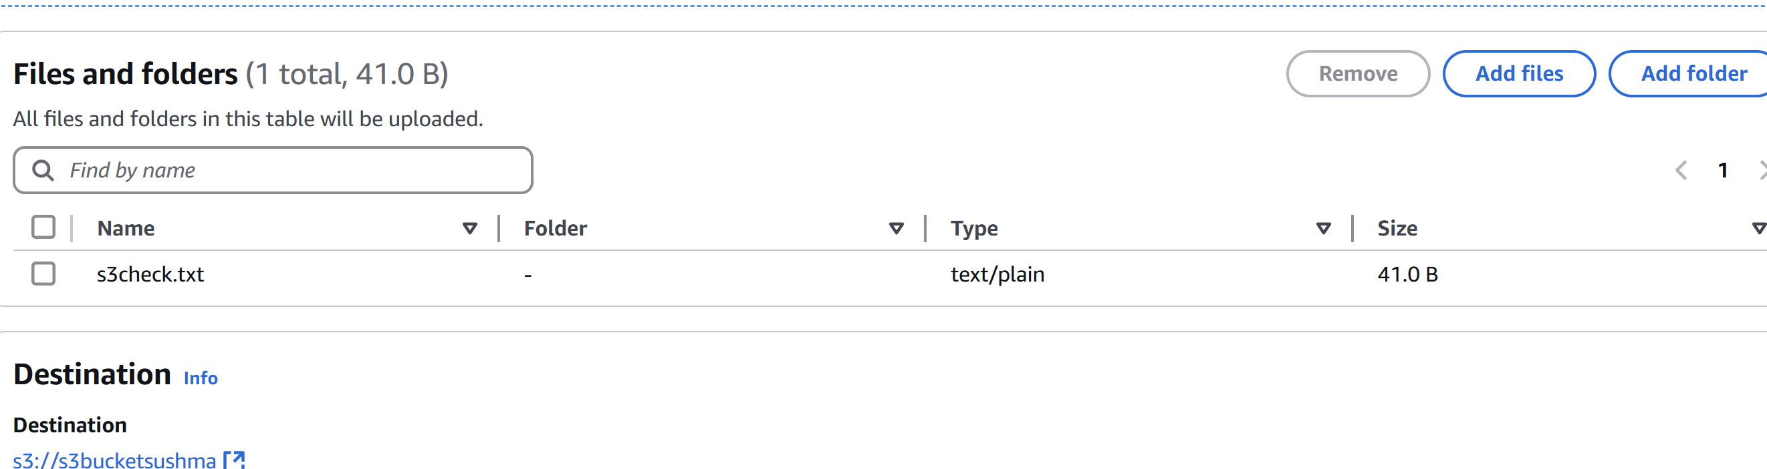

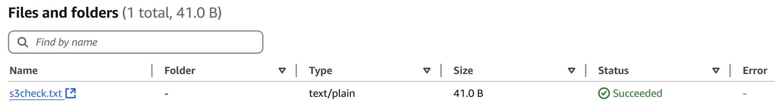

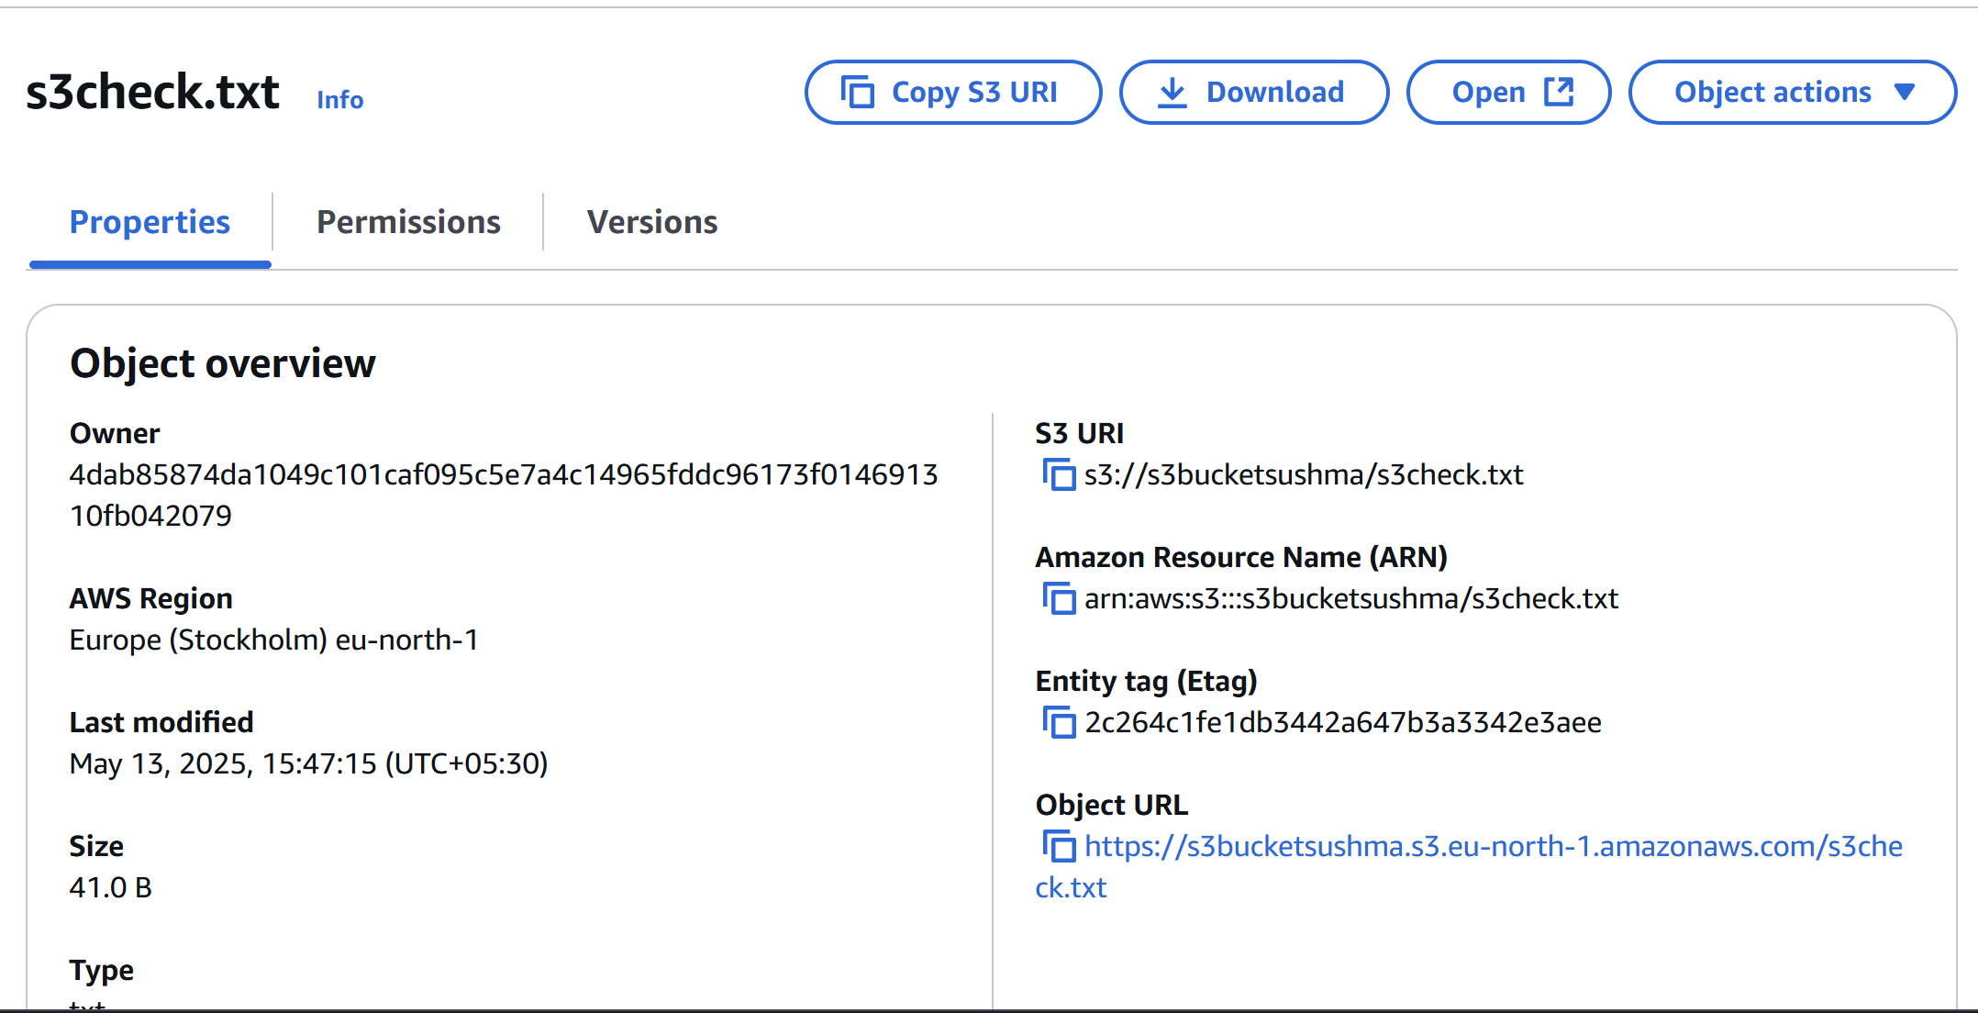

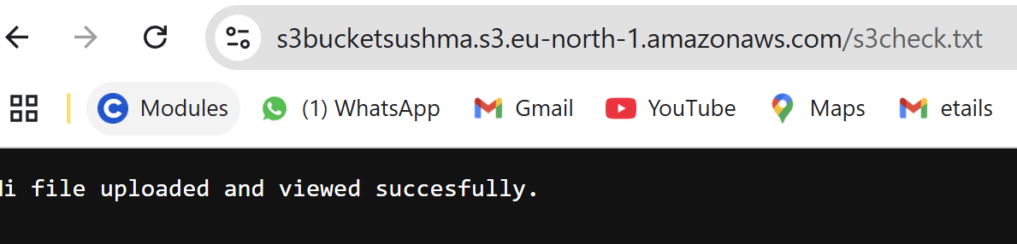

2) Deploy static website in s3 bucket.

* First we need to create two files here I am created as **index.html** and **error.html**

Which are used to get the page and error page.

* Then now go to **Buckets 🡪 select the bucket**

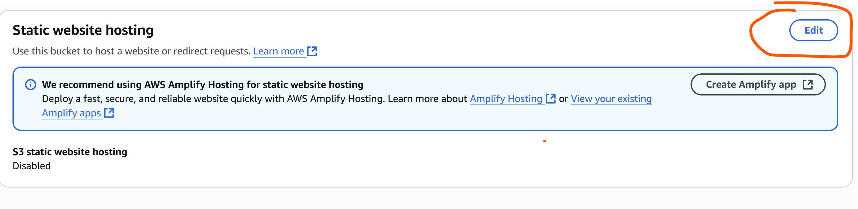

* Now go to  **properties -🡪 enable the static website hosting.**
* Select the Hosting type here I have selected **Static**

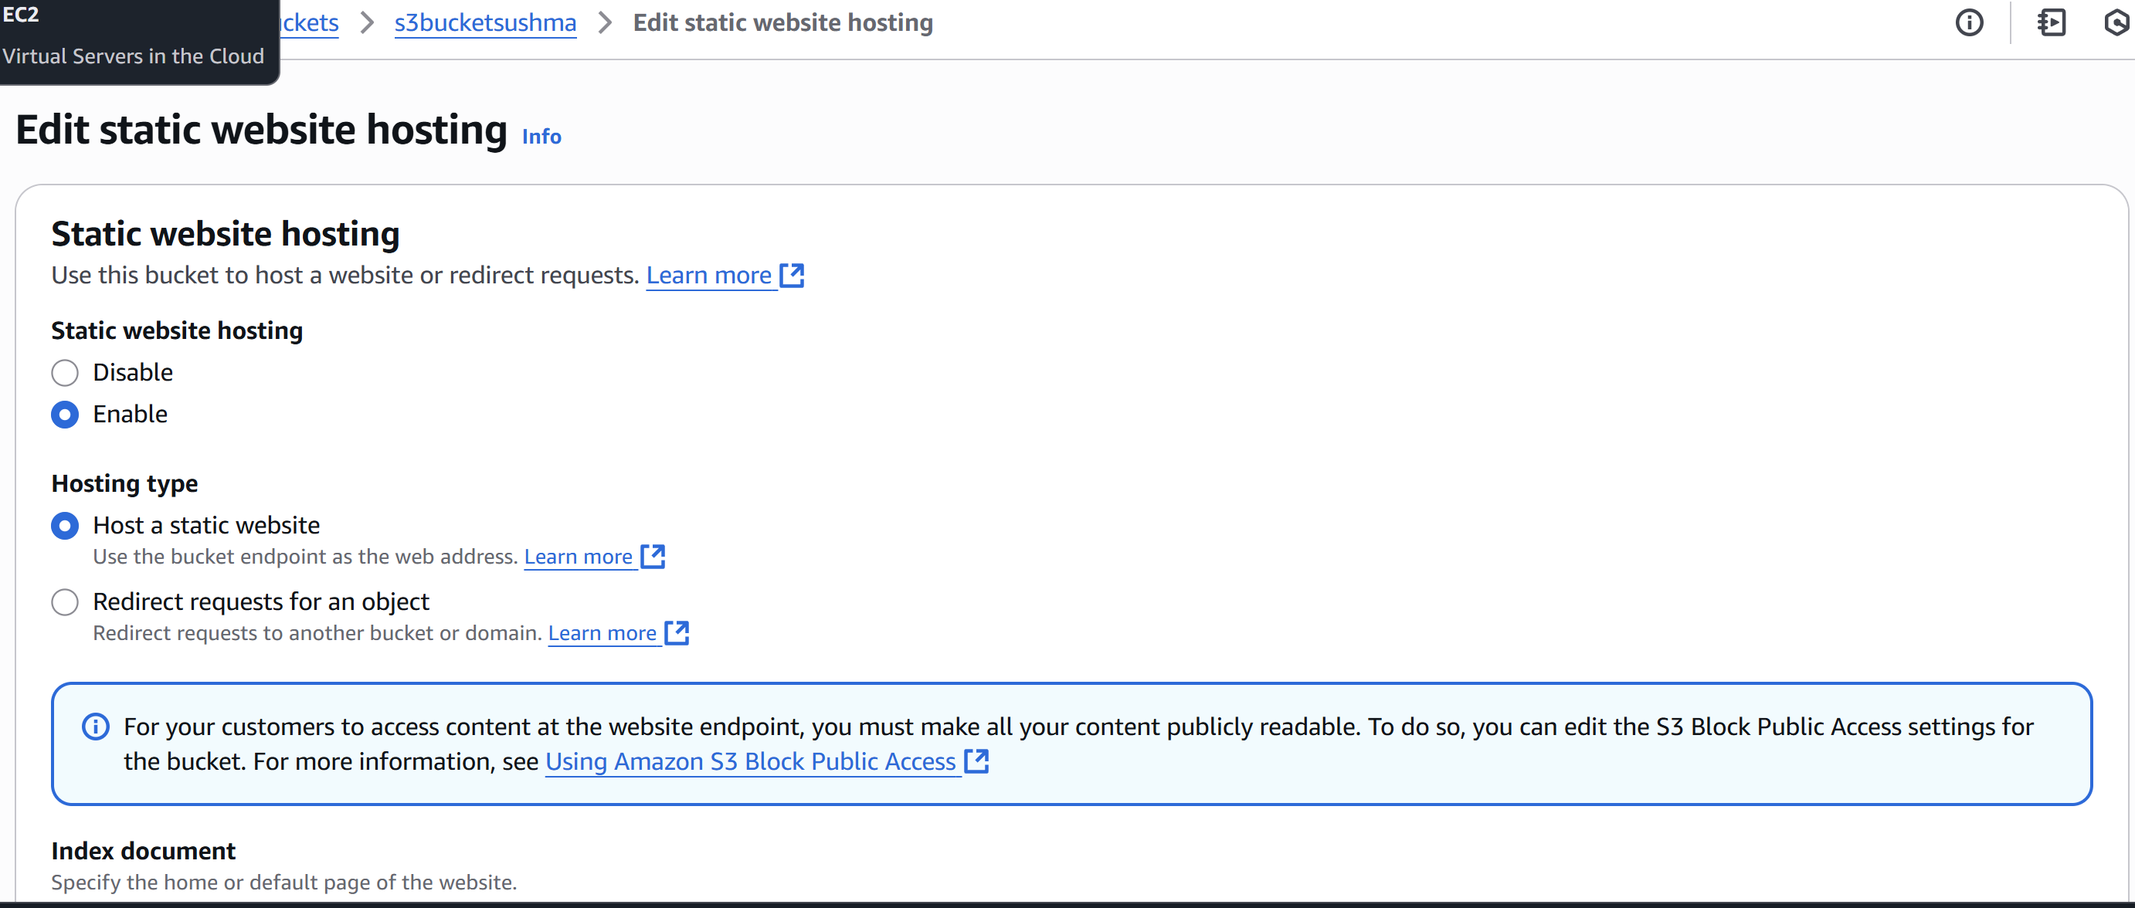

* Now enter the index object name which we uploaded in bucket **index.html and error.html** then save.

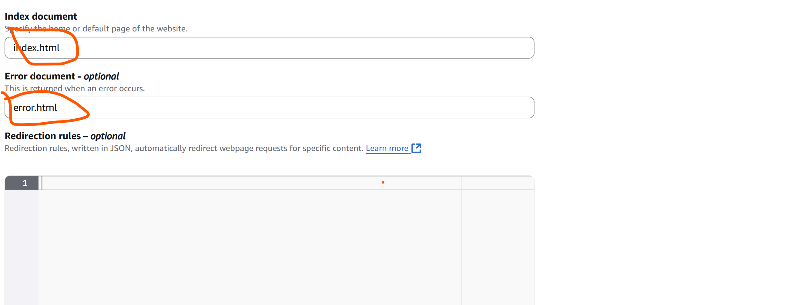

* Then go to the **bucket website endpoint**  and copy the link.

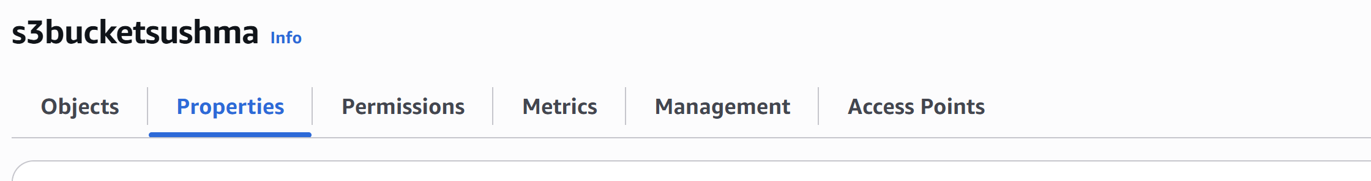

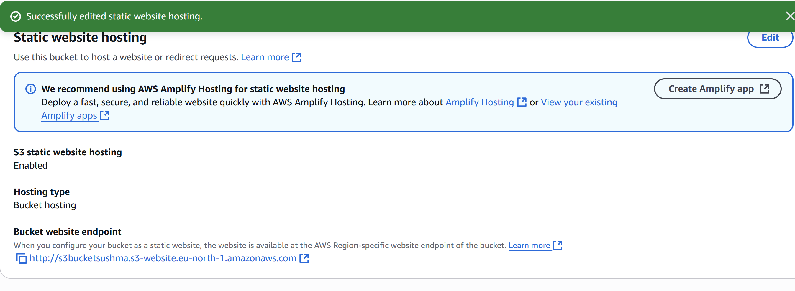

* Then deploy in the url then we will get the **Page with text which is in index.html**

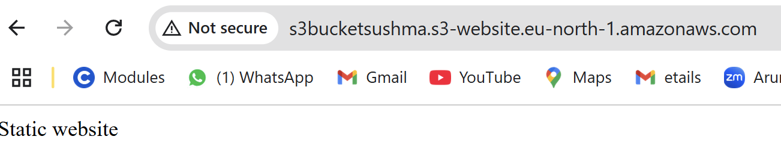

* Now once delete the index object in bucket

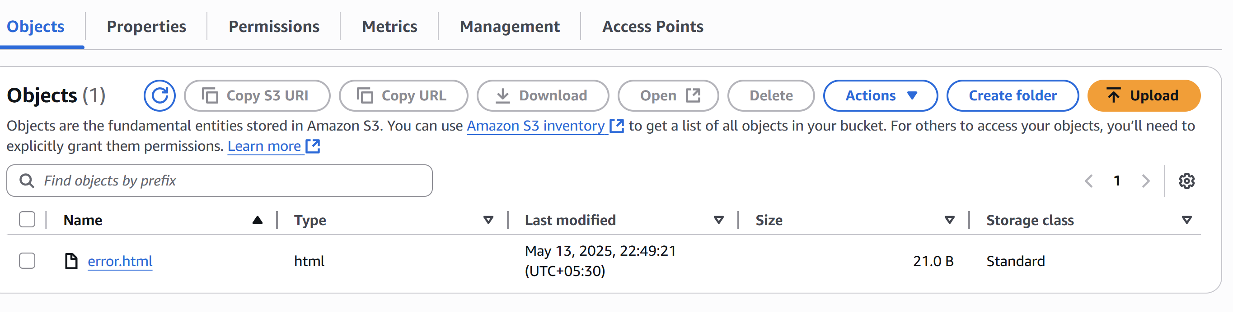

* Then try to reload the page then we will get the error message which is in error.html object.

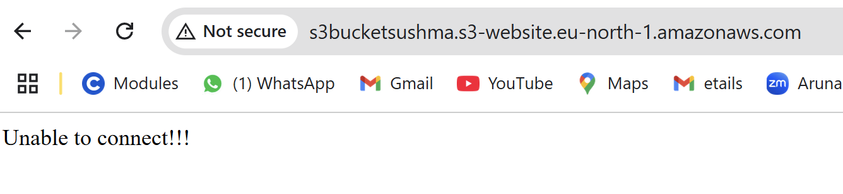

3) Enable cross region replication on s3 buckets.

* Create Destination Bucket

Go to S3 Console > Create bucket

Choose a different region than the source bucket

Enable versioning

Keep default block public access settings

* **Enable Versioning on the Source Bucket**

Go to the source bucket > Properties

Under Bucket Versioning, click Edit → Enable

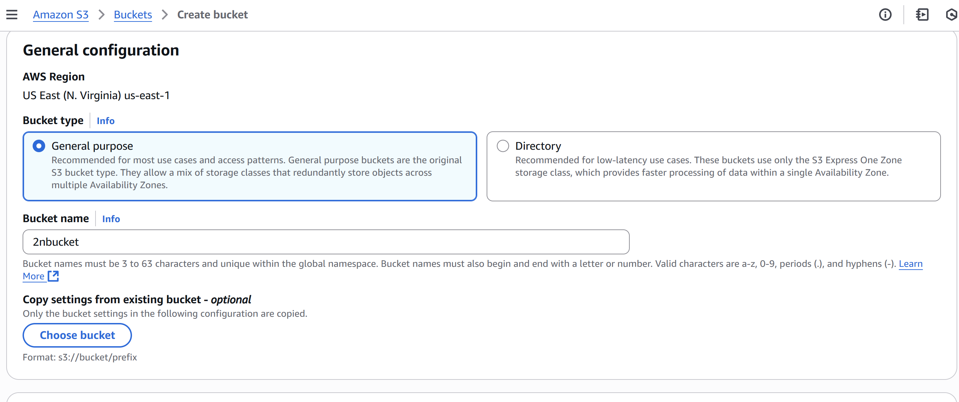

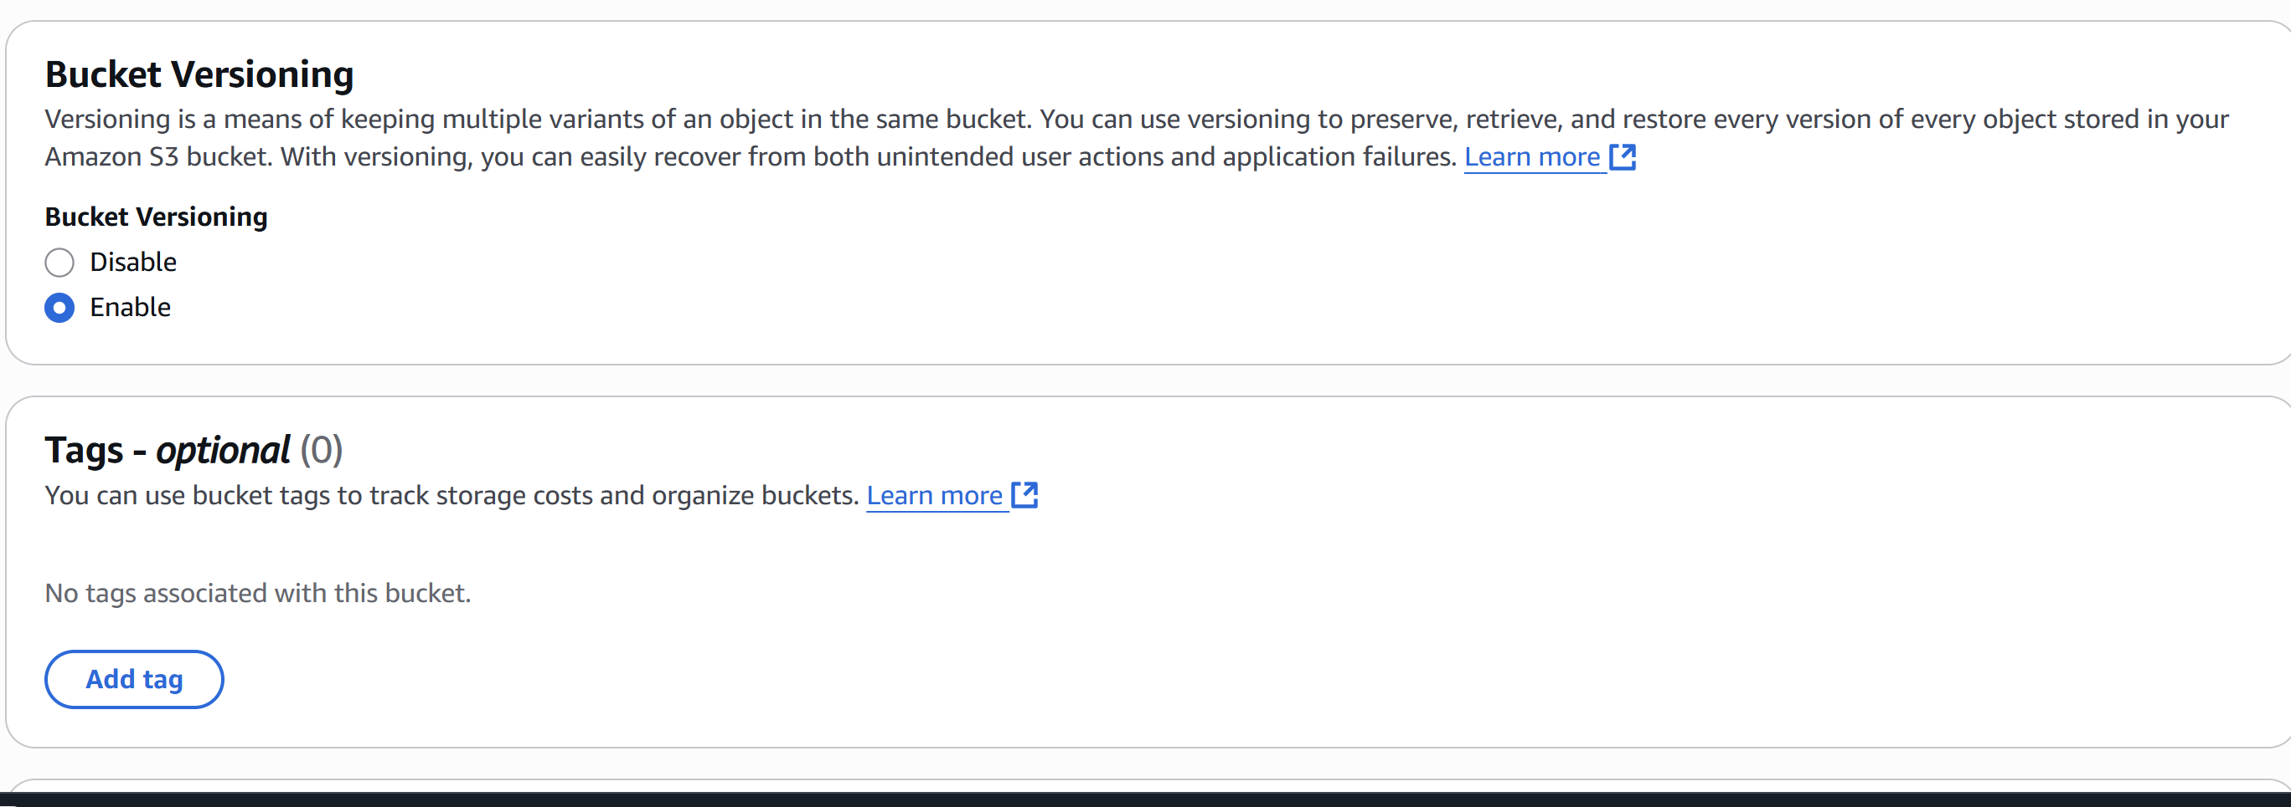

* Set Up Replication Rule

Go to Management > Replication rules → Create replication rule

Enter a name

Choose “Entire bucket” or a prefix filter

Select Destination bucket in another region

Choose an IAM role (auto-create or use the one from above)

Enable options like replication of delete markers, tags, etc.

Save

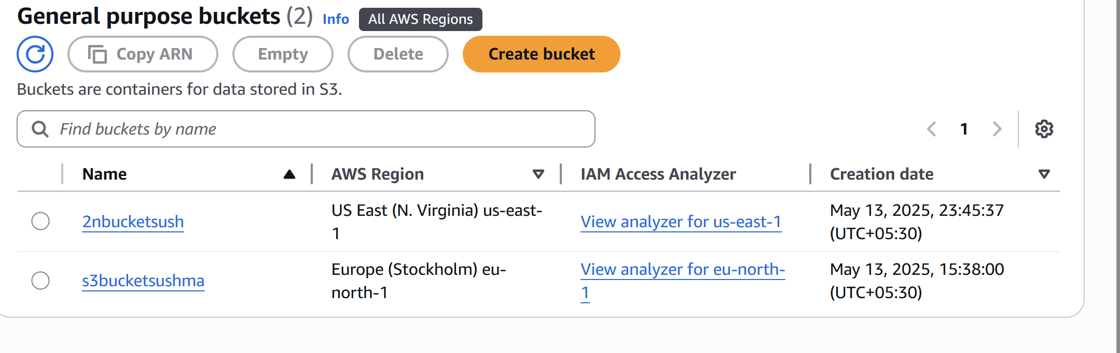

* Test Replication

Upload a file to the source bucket

Check the destination bucket after a few minutes

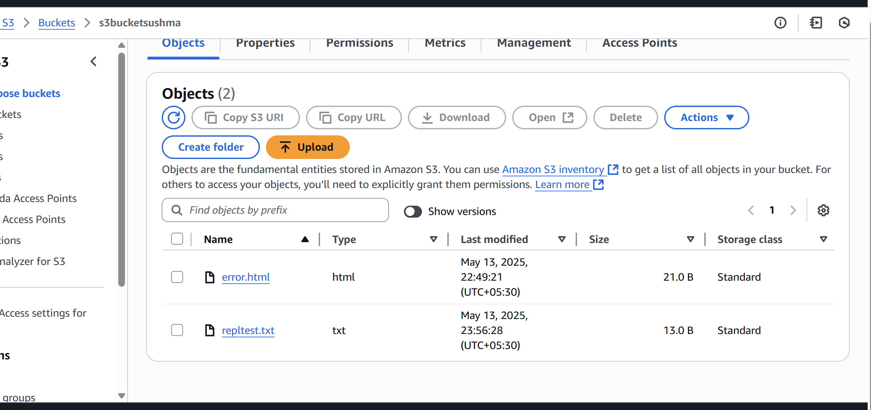

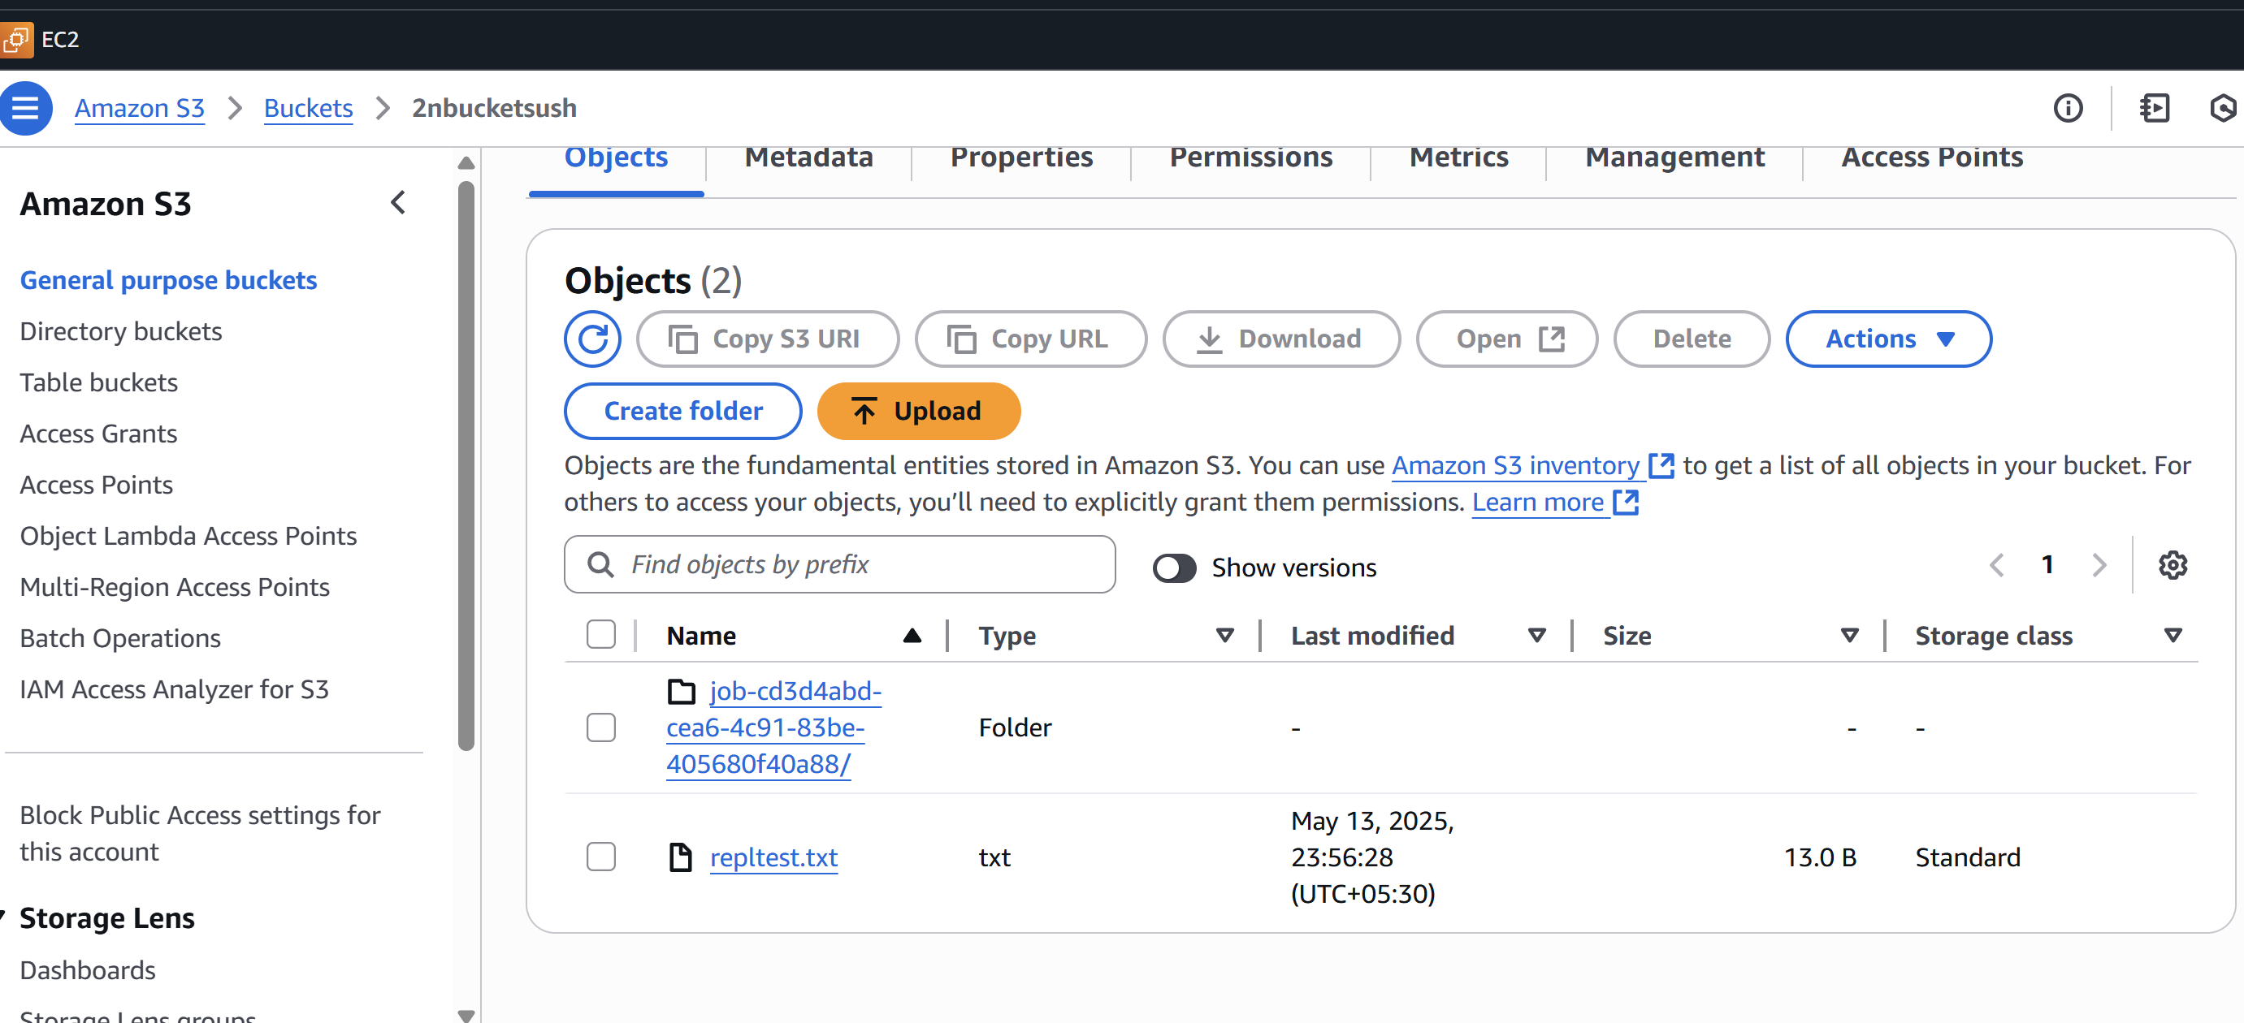

4) Configure bucket policy,only Admin user can see the objects of s3 bucket.

* You must know the ARN of the Admin user.  
  You can find it in the IAM console or using:  
  aws iam get-user --user-name test  
  Example ARN:  
  arn:aws:iam::750471539774:user/test  
  Bucket already exists.Step 1: Open AWS Console → S3 → Your Bucket  
  Go to the S3 console.  
  Click on your bucket name.  
  Go to the Permissions tab.  
  Scroll down to Bucket policy and click Edit.Step 2: Add Bucket Policy
* Json

{

"Version": "2012-10-17",

"Statement": [

{

"Sid": "AllowOnlyAdminUserAccess",

"Effect": "Deny",

"Principal": "*",

"Action": "s3:GetObject",

"Resource": "arn:aws:s3:::s3bucketsushma/*",

"Condition": {

"StringNotEquals": {

"aws:username": "Devops"

}

}

}

]

}

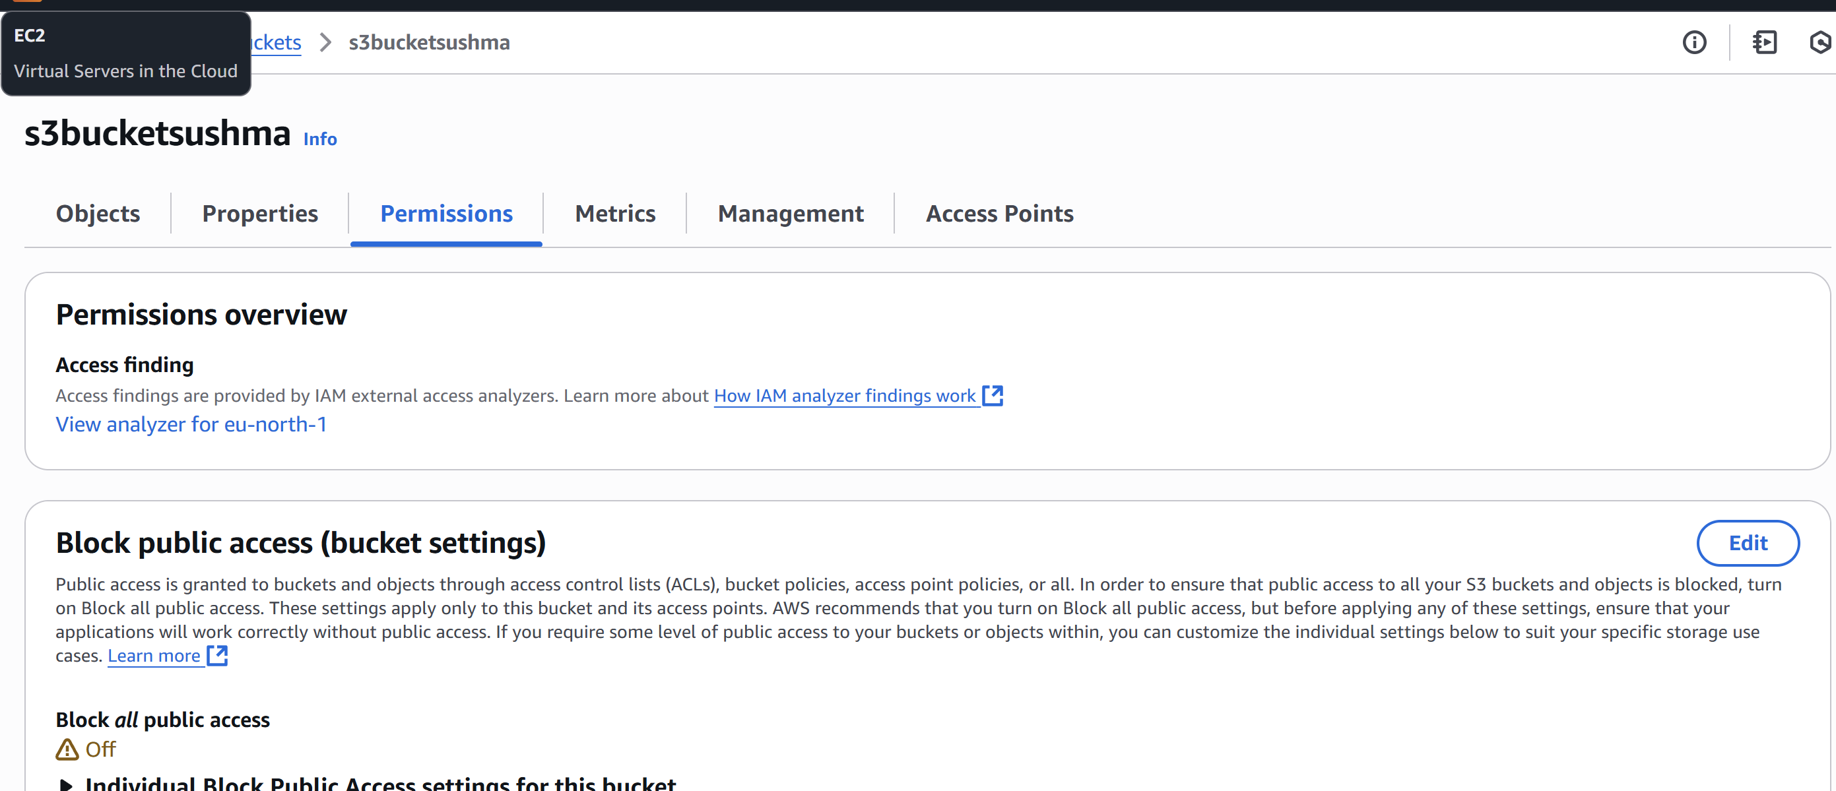

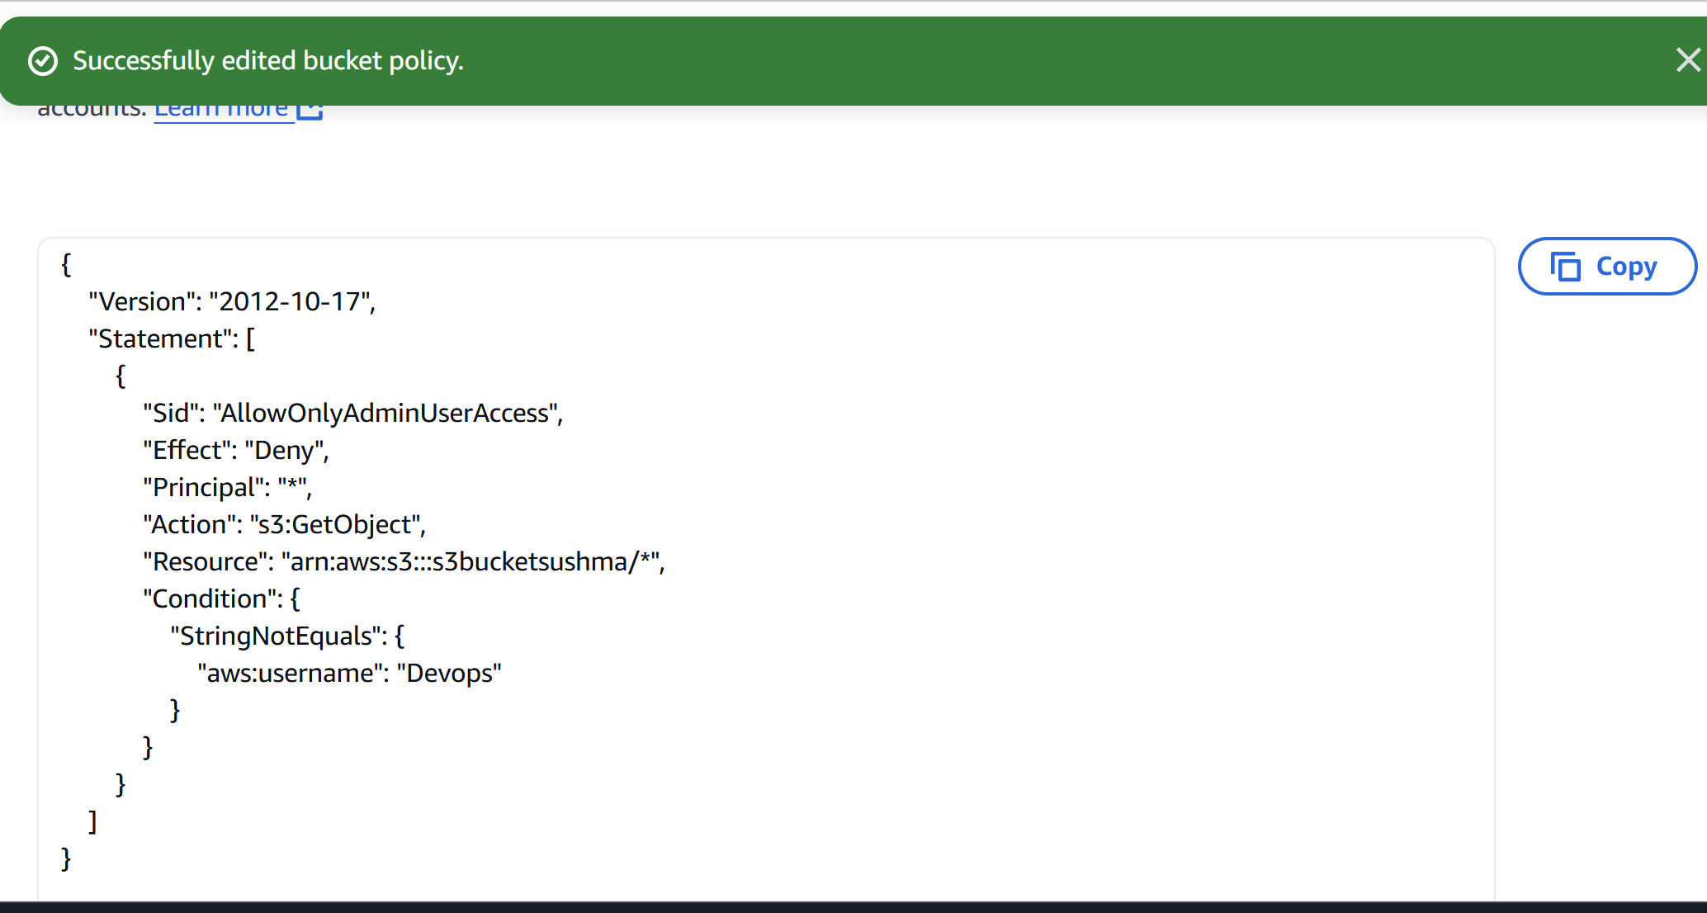

5) Setup lifecycle policies to automatically transition or delete objects based on specific criteria.

* Go to **S3 > [Your Bucket] > Management tab**
* Click **"Create lifecycle rule"**
* Give it a **name**
* Optionally, specify a **prefix** or **tag filter** to target specific objects
* **Choose transitions**:
* Transition to **Standard-IA** after 30 days
* **Enable expiration** (e.g., delete objects after 365 days)
* Click **Create rule**

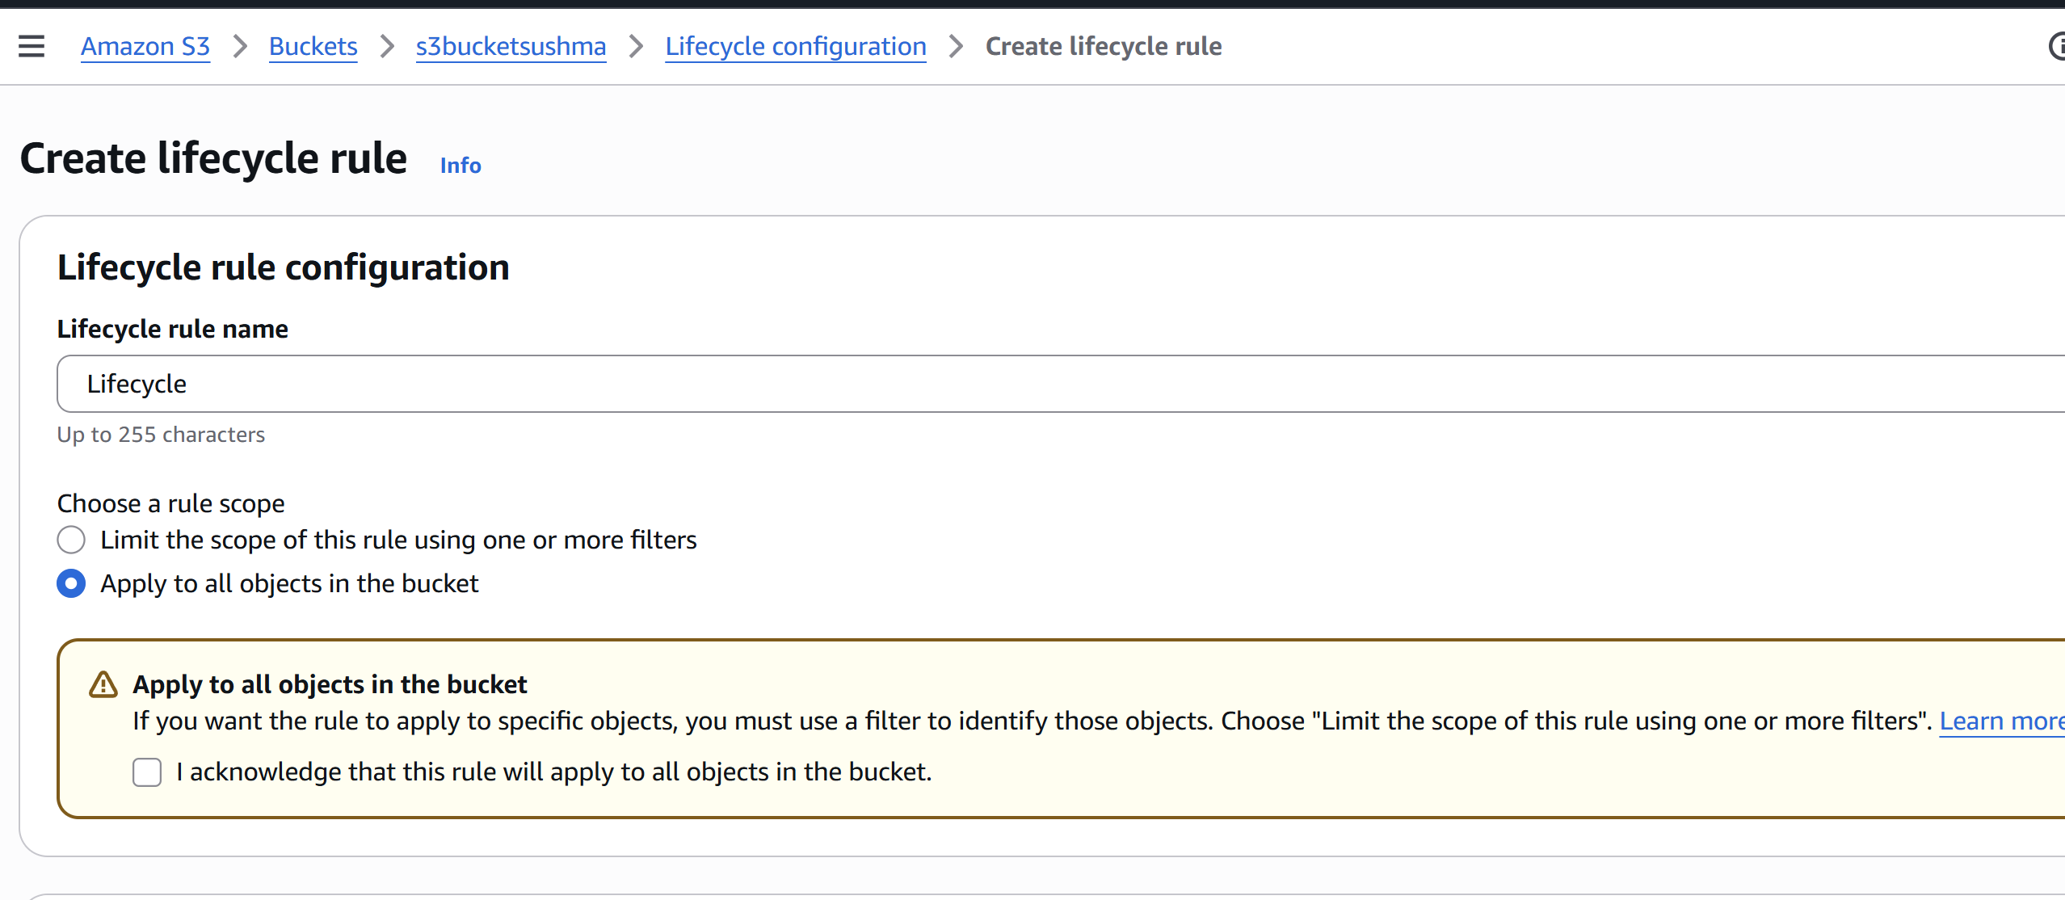

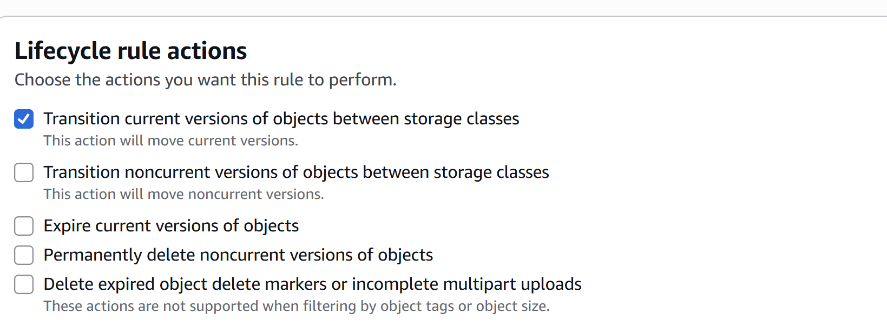

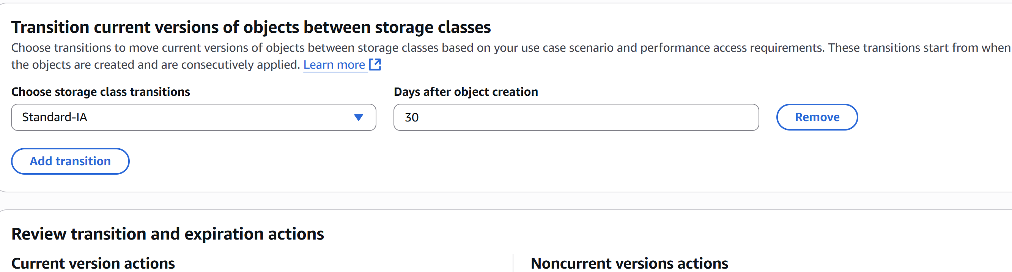

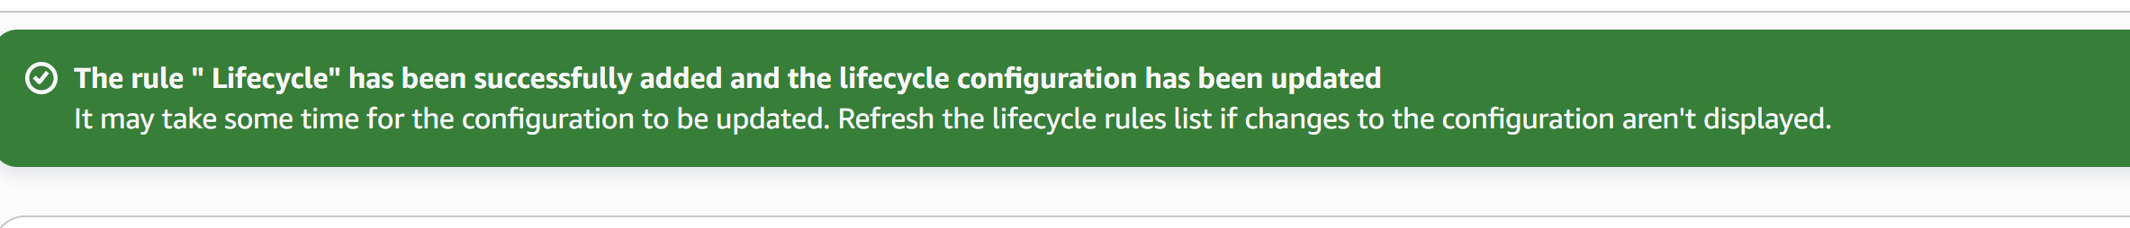

6) Push some objects in s3 using AWS CLI.

* Configured credentials: Run aws configure and enter your AWS access key, secret key, region, and output format.

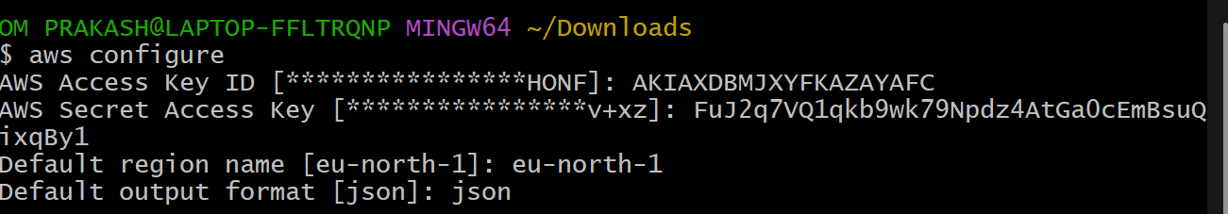

* To upload a single file to an S3 bucket:



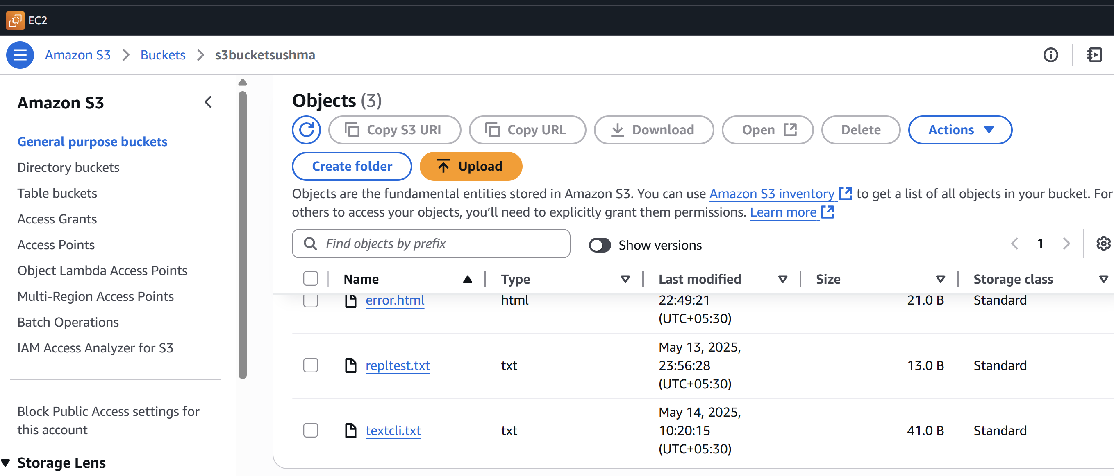

7) Write a bash script to create s3 bucket.

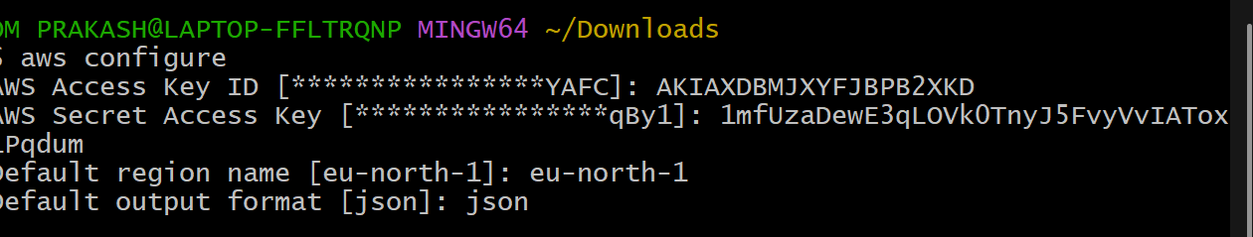

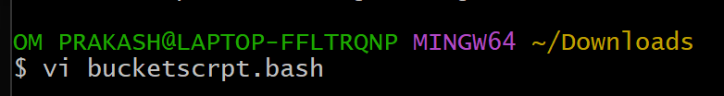

#!/bin/bash

# Check for required argument

if [ $# -lt 1 ]; then

echo "Usage: $0 <bucket-name> [region]"

exit 1

fi

BUCKET_NAME=$1

REGION=${2:-us-east-1} # Default region is us-east-1 if not provided

echo "Creating S3 bucket: $BUCKET_NAME in region: $REGION..."

# Create bucket

if [ "$REGION" == "us-east-1" ]; then

aws s3api create-bucket --bucket "$BUCKET_NAME"

else

aws s3api create-bucket --bucket "$BUCKET_NAME" \

--region "$REGION" \

--create-bucket-configuration LocationConstraint="$REGION"

fi

# Check if bucket was created successfully

if [ $? -eq 0 ]; then

echo "✅ Bucket '$BUCKET_NAME' created successfully."

else

echo "❌ Failed to create bucket."

fi

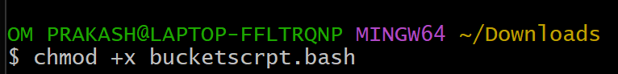

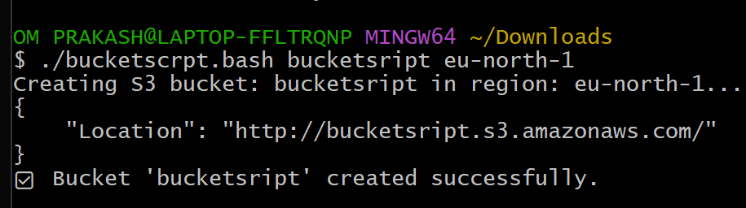

8) Upload one 1 gb of file to s3 using cli

